Google Classroom Training

April 12, 2016

Mrs. Slusarski E209

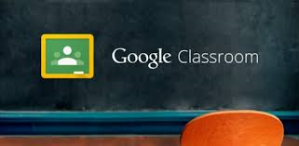

Google Classroom offers a one-stop platform for facilitating digital production, workflow, and communication between teachers and students.

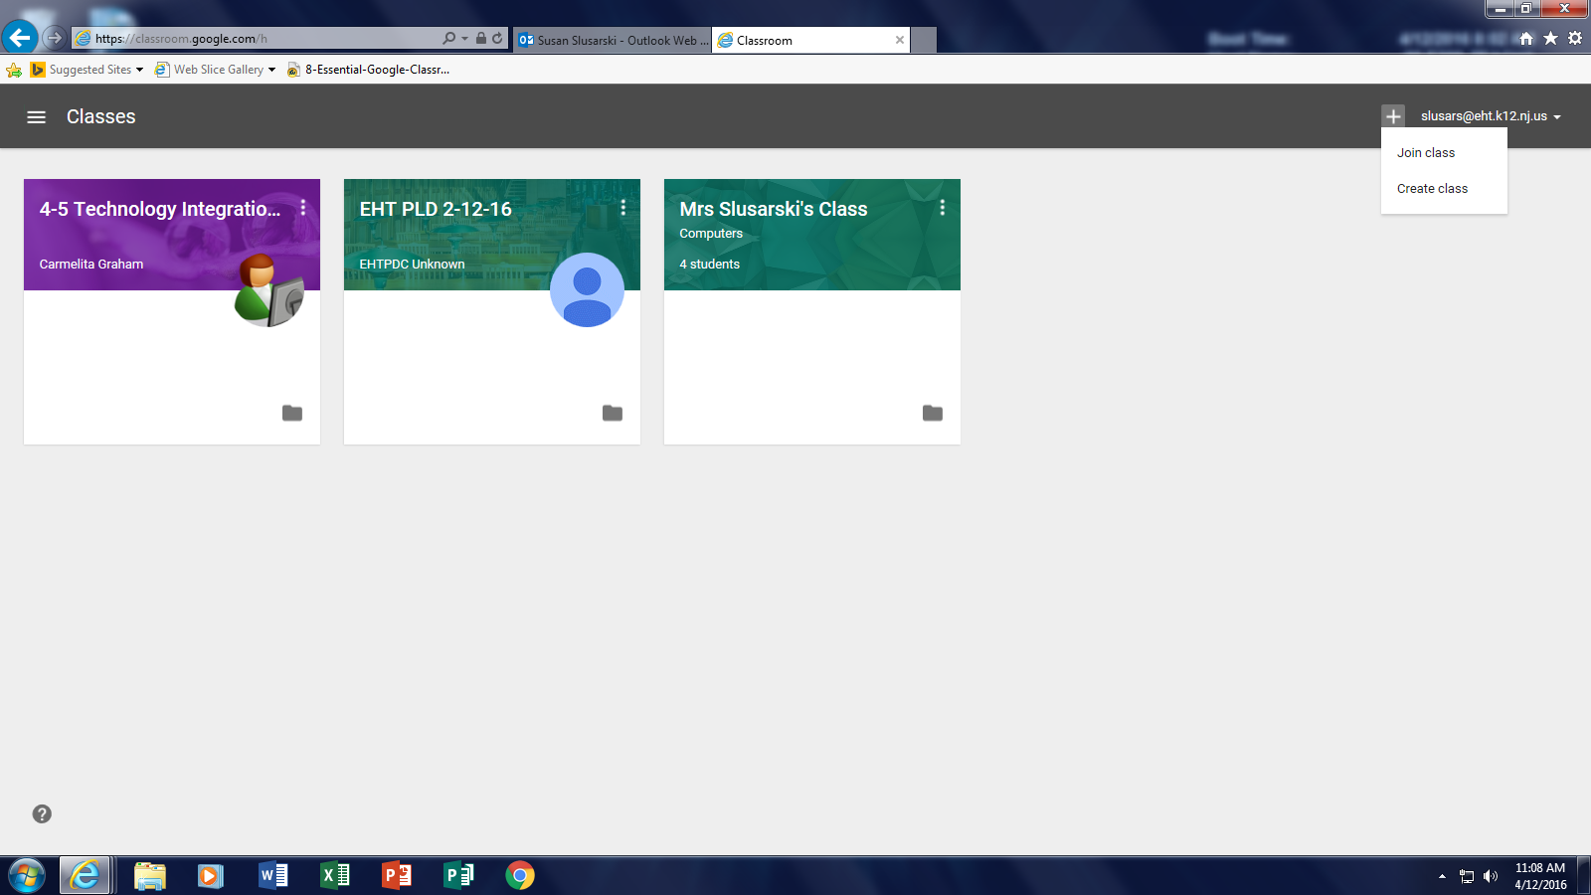

Click on the plus sign and click create class.

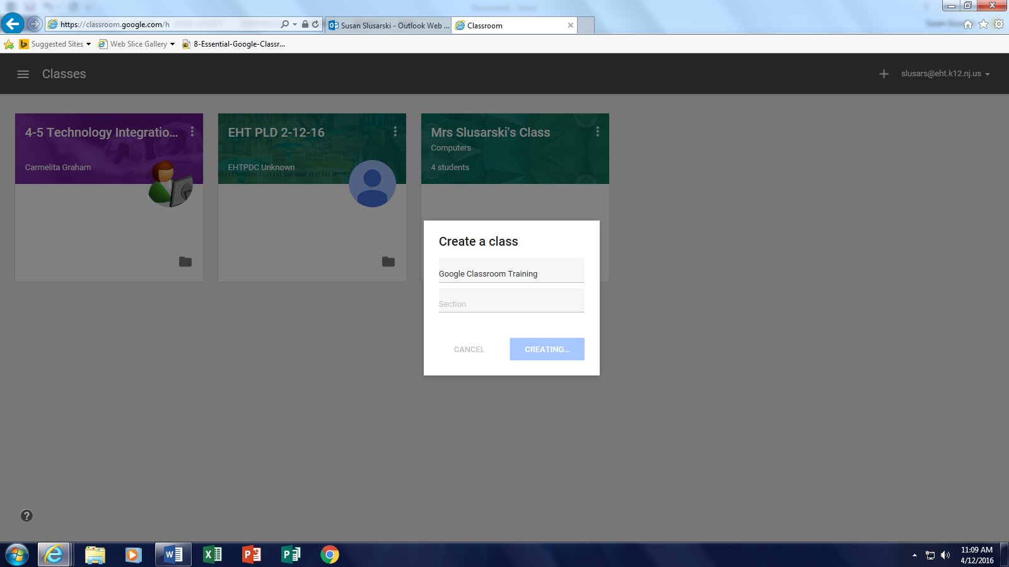

Now you can give your class a name.

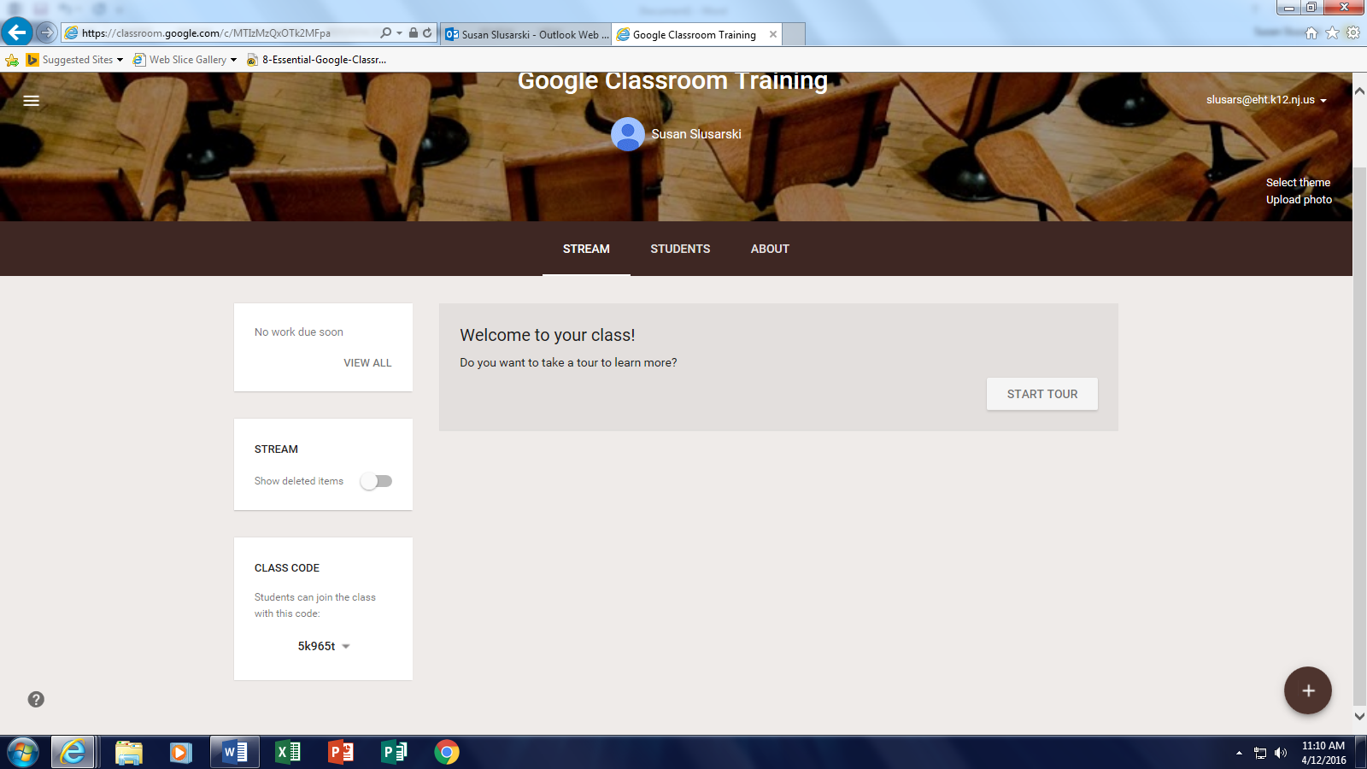

In the Students Tab, this will show you all the students in this class.

This is where you will add assignments

This is where you can change the header and the color.

This is the code you will give your students to get into your classroom

In the About tab, you can put your syllabus, rules, directions, and things that the students will need to access the entire year.

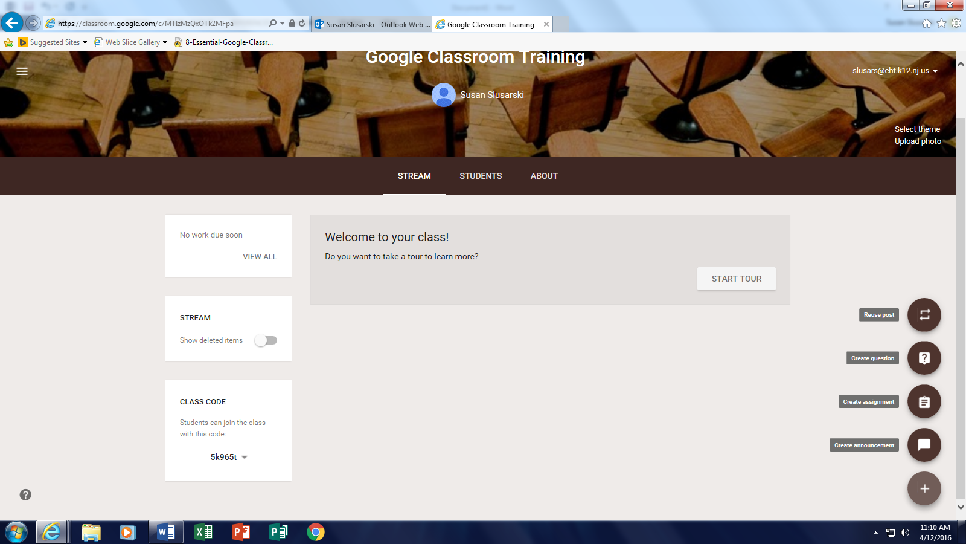

These are the types of assignments you can post.

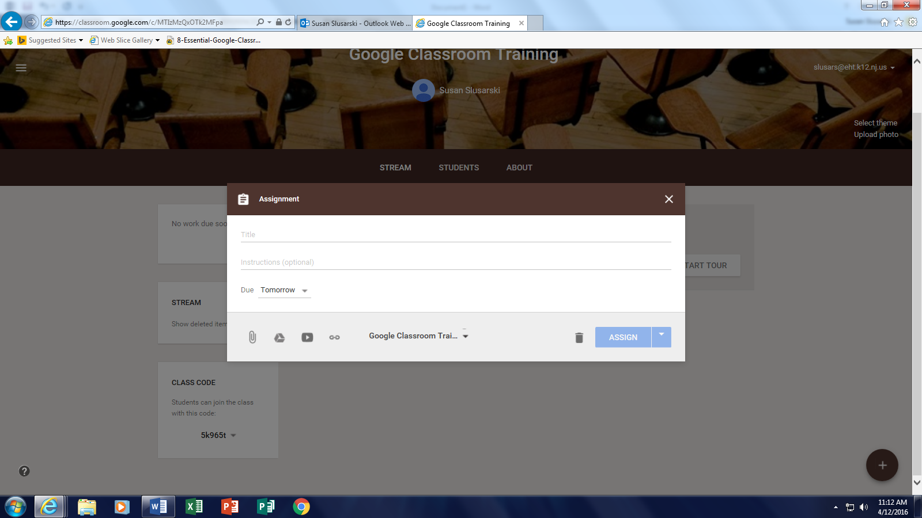

After you click on Assignment, name the assignment (I read to number assignments), add directions, due dates and time, and you can attach anything from your H drive or Google Drive.

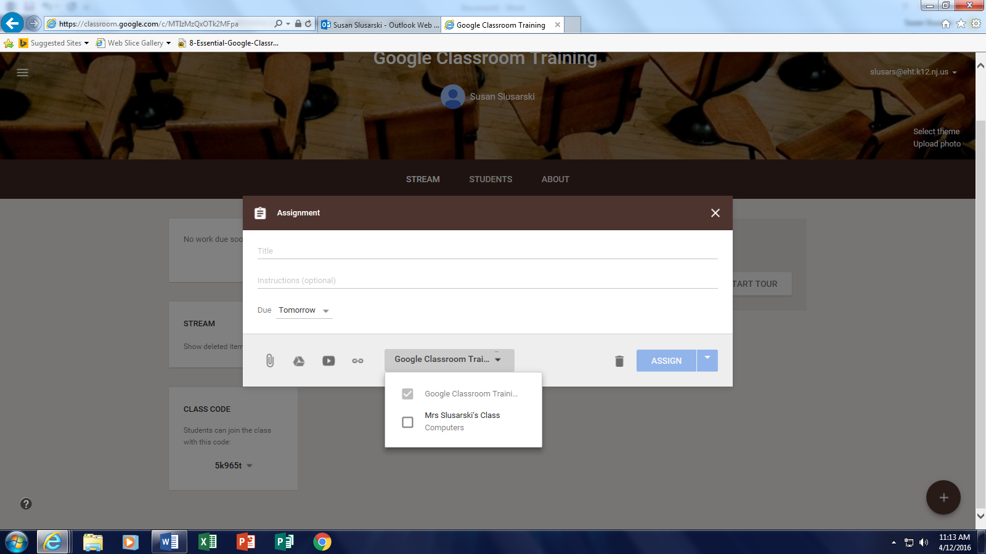

This is where you can attach, documents from your H-Drive, Google Drive, or upload videos.

Once you create the assignment you can add it to as many classrooms as you like.